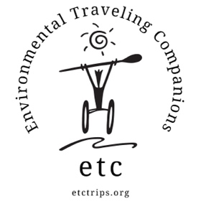

ETC RIVER PROGRAM PRICING

2025 SEASON

Group Trips
 | Program Group* | School/Camp | Benefit
Rafting | $80/person/day | $120/person/day | $180/person/day
Camping | $25/person/night | $25/person/night | 1 night included
Food** | $40/person/day | $40/person/day | Lunch included
- Program groups are those who serve people with disabilities or youth from under resourced backgrounds.
** Groups may provide their own food. Food can also be arranged on a per meal basis at the following costs:
Food pricing breakdown: Breakfast $10/person - Lunch $14/person - Dinner $16/person

Friends and Family Open Enrolment Weekends
 | 1-Day | 2-Day  1-Night
Individual Participant | $120*/person | $250**/person
*Shuttle and lunch provided, Friday camping
**Shuttles, 2 lunches, 1 dinner, 1 breakfast
Additional nights of camping (the night before or after a trip) is $20/person/night

ETC SEA KAYAKING PRICING 2025 SEASON

Group Trips
 | Program Group* | School/Camp | Benefit
Kayaking** | $65/person/day | $95/person/day | $110/person/day trip  $340/person/overnight
Overnight Fee | $20/person/night | $20/person/night
Food**** | $40/person/day | $40/person/day | See below***
* Program groups are those who serve people with disabilities or youth from under-resourced backgrounds.

** Kayaking cost is discounted 10% for trips of 3 or more days.
*** Benefit group overnight trips include all meals. Food can be provided for benefit day trips at an additional fee.

 Groups are encouraged to provide their own food. Food can also be arranged on a per- meal basis at the following costs: Breakfast $10/person - Lunch $14/person - Dinner $16/person

Open Enrollment Trips
Friends & Family Day Paddle  (Includes lunch) | $100
Friends & Family Overnight (Includes all food) | $250
Bioluminescence Paddle | $160
Moonlight Pizza Paddle  (Includes dinner) | $160

Prices are standard regardless of whether the trip is conducted on San Francisco Bay or Tomales Bay

ETC YOUTH LEADERSHIP PROGRAM PRICING
2025 SEASON

Youth LEAD Summer Courses
14-Day Courses | $3,850  $275 per day
21-Day Courses | $5,500  $262 per day
Rates include all meals and transportation during the course.

